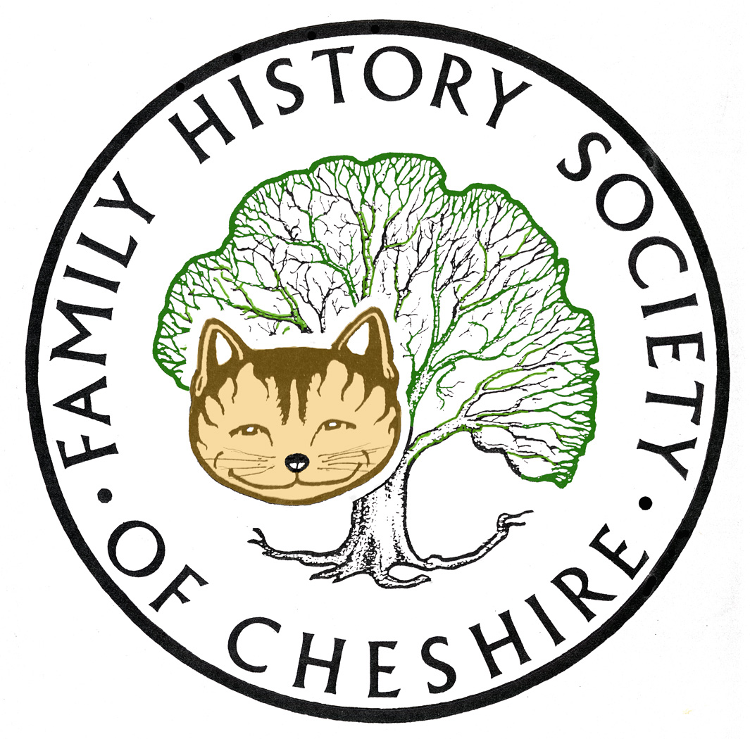
Family History Society of Cheshire
Tameside AGM 12 September 2018
Minutes of Last AGM, Agenda, Group Leader’s Report and Programme 2018 -19

Minutes of the last Meeting: Were read and accepted as a true record. Minutes and Reports for years ending 2015 and 2016 and 2017 are available via our website: fhsc.org.uk
Tameside Group > Library > Tameside Documents.

Matters Arising: There were no matters arising

Financial Report:

Last year we made a profit of £132.33 mainly due to having three speakers who didn’t charge

Election of Officers:

- Gay Oliver – Group Leader
- Treasurer – Janine Prince
- Adrian Brown – Library Help Sessions and help at meetings
- Angela Moore – main chauffeur to meetings at Mobberley and Budworth
- Secretary Pat Walker need a new secretary or at least someone to be a third signatory on our bank account – Angela Moore agreed to be our third signatory on our account
- David Mason –Events Organiser
- Jennifer Lever and Anita Wozniak – refreshments – standing down if no volunteers, I will create a rota and if this doesn’t work we will have no refreshments at meetings

Family History Detectives at the Library: Gay Oliver, Adrian Brown, Heather Brown, Maureen Etchells. I am hoping that David Mason will join us too.

Feedback from our Central Committee meetings at Mobberley Three of our Society Volunteers have resigned for various reasons. Maurice Stokes has resigned as Membership Renewals Secretary and Sue McNulty as new members secretary. We have a replacement for Maurice and Alan Bennett, our webmaster, has offered to help him for the first 12 months. At the moment we don’t have a replacement for Rosie Rowley as Editor of our Cheshire Ancestor.

Our website seems to have bedded in now and most gliches have been sorted out, I get very few emails now where members are having problems joining, forgetting passwords etc. Most of our Society Committee and Group Leaders are adding content to their allotted pages and they don’t seem to be having many problems anymore.

The main benefits of our new website being:

- The ability to join on-line
- More Transparency – many of our Society Documents are on Public View
- Hoping to build upon providing more for our members under the My Membership menu
- Hopefully our Shop will be launched soon, where we hope members will be able to download directly PDFS for a small charge for Monumental Inscriptions, Parish Registers etc
- Space to add your stories and surnames and groups to add galleries of photos
- To be able to download Journals from other Societies worldwide
- To subscribe to newsletters

It should eventually provide a more immersive experience.

This year our Group Allocation has been increased by £100 to £500. I’m pleased about this since it is getting progressively harder to find speakers and those who still do talks are charging more. Thank you Victoria.

The Society is moving forward to working more in partnership with Chester Record Office and the CRO’s move to new premises.

Annual Group Leader’s Report:

I want to thank the following Volunteers and those who help at our Local Studies Library: Gay Oliver, Maureen Etchells, Adrian Brown and Jenny Lever, Kate Booth, David Mason, Heather Brown. Thanks to everyone who helps and stands in at a moment’s notice. There are many other projects our group could start, but we need more volunteers. Heather is helping to advertise these sessions, because we want more customers and our Local Studies library needs to keep its attendance figures high. Would also be good if those attending the sessions could be persuaded to join our society or come to our meetings for all the free help they get

Chauffeurs to Meetings at Anderton: This year I managed to attend all of our quarterly Executive Committee Meetings, with very many thanks to Angela Moore, whose feedback from these meetings I much appreciate Angela has also taken me to a couple of Group Leaders meetings. Adrian Brown has also stood in when Angela is unavailable. If I was just a group leader, I could possibly miss one or two of these meetings, but in my role as Web Administration my presence is definitely required. This year I only missed one meeting due to snow

Cheshire BMD Up-date: No up-date to Tameside indexes, because these are virtually complete and will be added to as various churches complete and deposit their marriage registers.

Problems getting interesting and varied speakers:

I continue to try and arrange popular and informative sessions, but can never work out which sessions will attract the most attendance even accounting for the weather. I try to take account of reviews of talks given to other groups to test how popular they will be. Many speakers I contact have stopped giving talks, so it gets more and more difficult and I have to look further and further afield. This year I feel the talks by Kate Booth about the Spanish Flu, the talk about the Cross Street Burials and Peter Braun’s talk about Royalty and Dunham Massey were particularly popular from the feed back I received.

I also continue to produce a monthly newsletter, which is now circulated to our members, Tameside History Forum, and all ex members of my classes – a total of 248. I am in transition of starting to use our website to send out my newsletters and you will have noticed the new template. The new system is supposedly more secure, personalized and less likely to be categorized as spam. I’m hoping this gives those who can’t attend meetings some added value and that it might encourage more people to attend our meetings or come along to our Library sessions for help.

Other Activities:

Recent Projects:

The theme for Heritage Open days this year is Women to celebrate their partial enfranchisement 100 years ago. A few months ago Kate Booth and myself thought we could compile a leaflet about Extraordinary Women from Tameside thinking we would find about a dozen to write about – this mushroomed into around 80 women and resulted in the book and display you will see at our meeting on Wednesday. If you can’t pick up a copy locally at Heritage Open Day events, you can apply here online: www.tamesidefamilyhistory.co.uk/women.index.html

In May this year Adrian Brown and myself were approached by the producer of a new programme by Wall to Wall TV, “Coronation Street’s DNA Secrets” particularly Sally Ann Matthew’s DNA match to another Corrie Legend. Other people helped with background research, Heather Brown from our Help Desk in the Library and Norman Bamforth our local everything to do with mining expert in Tameside. Adrian spent a day at Wakelfield Mining Museum filming with Sally Ann and showing what it would have been like for her 3 times great grandfather, aged 10, to go down the mine. Sadly all this was cut as the scope of the programme grew and everything had to be compressed. Very sad because he had prepared masses of background material. It wasn’t wasted though, because he gave Sally Ann a presentation pack for her to take away.

I then spent the following day filming in Ashton Old Baths, The producer was particularly impressed with this as a venue for filming… It was a genuine reveal. They had to hide Amanda Barrie when she entered the building until it was time for the reveal. They missed out quite a bit, particularly Sally Ann asking what it would have been like for a single mother in 1840.

Both Adrian and I were genuinely happy to be involved, Sally Ann was delightful and the film crew were so easy to work with

Older Projects

- I helped to run a Training Session for Chapel members about the history of some of their members buried in their churchyard.

- I was also involved Greater Manchester Archaeology Days with a display about Women from Tameside and gave a talk about Egyptologists from Tameside

- Also a talk to Stalybridge Congregational Church about some of the families buried on the Old Chapel Graveyard.

I also run our FHSC Committee pages aimed at encouraging more effective communication between officers of the Society. Here we have a document library to store all Society, Agendas, Minutes, Reports, Membership Lists, and Constitution, and entire archive back to 1969 etc – anything that helps to keep material for the effective running of our society in one place. This year I have been adding more and more exchange journals from other societies

I haven’t been able to up-date all the research guides I compile and add to my own Tameside website and to the society’s website, will get to these as soon as possible. The following are online:
Beginners' Corner:
Researching Your Family's History
Pedigree Starter Chart
Getting Started
Interviewing Older Relatives
To Compute or not to Compute
Learn Computing
Now to Begin Filling in the Gaps in your Pedigree Starter Chart
Reminders and for those with More Experience:
Maps for Family Historians
Birth, Marriage and Death Certificates
Census Returns
Trade Directories
Parish Registers and New Family Search and the I.G.I.
Wills and Probate Records
Newspapers and Family History
1841 Census Example
Example Parish Register Documents Part One
Example Parish Register Documents Part Two

This section now has the added facility to include members’ long articles. These are articles about their Family History which are far too long for the Ancestor, but possibly rather too short for self publication. Please take the opportunity to look at this new section and think about submitting your own stories.

More material will be added here as time goes on

Our Community toolbar became defunct this year due to its insertion of malware on members’ computers, so I spent a considerable amount of time adding all the links to our new site.

Our Group is still a member of Tameside Local History Forum, where I also run their website, social media, and am joint editor of any publicity materials. Our Forum has 16 member groups whose content needs up-dating regarding forthcoming events on a regular basis: www.tamesidehistoryforum.org.uk

I continue to develop my own Tameside Family History website www.tamesidefamilyhistory.co.uk to keep it as up-to-date as possible with sources and information available to people researching their family history in Tameside. This was last up-dated at the end of August.

I have also been gathering together a page for all the WW1 projects happening in Tameside:
www.tamesidehistoryforum.org.uk/ww1.html Kate Booth and I are hoping to add a complete inventory of War Memorials in Tameside to this page very soon

I have put together two talks and displays 1) concerning the Dukinfield Family and their links to their slave plantations in North Carolina and Jamaica, 2) concerning all the problems of setting up the New Poor Law in Ashton-under-Lyne, which took seventeen years to fully implement. I have eight other talks.

- one about ‘Blind Jack of Knaresborough’, Famous Yorkshireman and Road Builder whose descendents all ended up in Cheshire
- Prophet John Wroe and the Christian Israelites – Ashton’s New Jerusalem
- Robert Reschid Stanley, Mayor of Stalybridge who converted to Islam in Victorian times and went on to lead the embryonic Moslem Community in Manchester
- How DNA revealed my grandfather was illegitimate and how it helped to unlock my Irish Ancestry
- Non Conformity in Dukinfield and some links with America
- The History of Photography and Dating old Photos
- NEW Egyptologists from Tameside
- NEW Irish Family History

I am also working on one about The Armitage Family linked to our church and their links to Pennsylvania, Ceylon and Rio, Brazil and, possibly about another Family buried in this Chapel. Charles Timothy Bradbury, from Saddleworth Buckton Grange in Carrbrook, Riversvale Hall in Ashton and his family’s links to Flinders Petrie and Egyptology. This talk is virtually complete now

Programme 2017-2018
September 12 – AGM plus Women from Tameside– Kate Booth and Gay Oliver. Also Adrian Brown on the background to our help with the Coronation Street DNA Secrets programme.
Our AGM should only take about 10 minutes so please don’t be put off attending
October 10 Rita Vaughan on Mossley’s Military Hospital
November 14 - Sex and Sin in 17th Century Lancashire – Alan Crosby
Alan is a national speaker and writes for the WDYTYA Magazine
Dr Crosby said that there was great emphasis on puritanism and morality in the 1600s and documentary sources were abundant. Serious crimes meriting the death penalty were dealt with by the Assize court in Lancaster. Lesser crimes went before the Quarter Sessions held at Epiphany, Easter, Midsummer and Michaelmas originally in Lancaster and Preston and later in other towns including Ormskirk and Wigan. Church courts dealt with crimes reported by the churchwardens and punishments were excommunication or public humiliation.
Quarter Sessions records are a rich source of information regarding sexual misconduct, bastardy and the operation of the poor law. Unmarried mothers were encouraged to relocate to a neighbouring parish before giving birth, interrogated (even in labour) to reveal the identity of the father so that a maintenance agreement for the child up to age 14 could be enforced. Women were sent to a house of correction for three weeks or more and soundly whipped. Dr Crosby read numerous examples.
Divorce was dealt with by the Church courts in cases where there were no formal documents. Annulment could be granted on the grounds of non-consummation, consanguinity or a technical difficulty.
Review by Ormskirk District Historical Society 2012
December 12 – Christmas Social
January 9 – The Murphy Riots – Gay Oliver About four years ago I had access to the home Office papers concerning these riots. What led up to them, the signing up of special constables and telegrams going back and forth to the to the home office.
I have a couple of ideas waiting to be confirmed to fill the gaps and will let people know as I confirm dates.

- Andrew Parker to talk about the history of local Unitarian churches.
- Ian Cameron- about his ancestors journey by Wagon Train across America

If anyone has been to an interesting talk recently please get in touch
David Mason is talking about organising a visit to the Family History conference in London next April and I would like to visit the People’s History Museum in time for the 200th anniversary of Peterloo

Any Other Business:

Date of next AGM 11th September 2019

Gay Oliver, Tameside Group Leader and Web Administration
8 September 2018

My main project this year is still Miss Caitlyn Jeanne Oliver aged 7 and the school run.

